***TASK # 01***

*Create Calculator application and persist result in shared preferences.*

***CODE***

***JAVA***

*package com.example.lab12;  
import android.content.SharedPreferences;  
import android.support.v7.app.AppCompatActivity;  
import android.os.Bundle;  
import android.util.Log;  
import android.view.Gravity;  
import android.view.View;  
import android.widget.Button;  
import android.widget.TextView;  
import android.widget.Toast;  
public class MainActivity extends AppCompatActivity {  
 public static final String SHARED_PREFS = "sharedPrefs";  
 public static final String TEXT = "text";  
 TextView textView;  
 private String text;  
 @Override  
 protected void onCreate(Bundle savedInstanceState) {  
 super.onCreate(savedInstanceState);  
 setContentView(R.layout.activity_main);  
 textView = (TextView)findViewById(R.id.result_text_view);  
 loadData();  
 updateViews(); }  
 public void applyToast(View v){  
 Toast t = Toast.makeText(this,"this is text",Toast.LENGTH_SHORT);  
 t.setGravity(Gravity.CENTER_HORIZONTAL,0,0);  
 t.show(); }  
 public void buttonClear(View v){  
 TextView text = (TextView)findViewById(R.id.result_text_view);  
 text.setText("0"); }  
 public void addValueInView(View v){  
 Button btn = (Button) v;  
 String text = btn.getText().toString();  
  
 TextView view = (TextView)findViewById(R.id.result_text_view);  
 if(view.getText().toString().equals("0")){  
 view.setText("");  
 view.append(text); }  
 else{  
 view.append(text); } }  
 public void buttonDivide(View v){  
 v = (TextView)findViewById(R.id.result_text_view);  
 ((TextView)v).append("/"); }  
 public void buttonMultiply(View v){  
 v = (TextView)findViewById(R.id.result_text_view);  
 ((TextView)v).append("*"); }  
 public void buttonSubtract(View v){  
 v = (TextView)findViewById(R.id.result_text_view);  
 ((TextView)v).append("-"); }  
 public void buttonAdd(View v){  
 v = (TextView)findViewById(R.id.result_text_view);  
  
 ((TextView)v).append("+"); }  
 public void buttonEqual(View v){  
 v = (TextView)findViewById(R.id.result_text_view);  
 try {  
 if (((TextView) v).getText().toString().contains("/")) {  
 int index = ((TextView) v).getText().toString().indexOf('/');  
 String stringNum1 = ((TextView) v).getText().toString().substring(0, index);  
 String stringNum2 = ((TextView) v).getText().toString().substring(index+1);  
 double num1 = Double.valueOf(stringNum1);  
 double num2 = Double.valueOf(stringNum2);  
 double ans = num1 / num2;  
 ((TextView) v).setText(String.valueOf(ans)); }  
 else if (((TextView) v).getText().toString().contains("+")) {  
 int index = ((TextView) v).getText().toString().indexOf('+');  
 String stringNum1 = ((TextView) v).getText().toString().substring(0, index);  
 String stringNum2 = ((TextView) v).getText().toString().substring(index+1);  
 double num1 = Double.valueOf(stringNum1);  
 double num2 = Double.valueOf(stringNum2);  
 double ans = num1 + num2;  
 ((TextView) v).setText(String.valueOf(ans)); }  
 else if (((TextView) v).getText().toString().contains("*")) {  
 int index = ((TextView) v).getText().toString().indexOf('*');  
 String stringNum1 = ((TextView) v).getText().toString().substring(0, index);  
 String stringNum2 = ((TextView) v).getText().toString().substring(index+1);  
 double num1 = Double.valueOf(stringNum1);  
 double num2 = Double.valueOf(stringNum2);  
 double ans = num1*num2;  
 ((TextView) v).setText(String.valueOf(ans)); }  
 else if (((TextView) v).getText().toString().contains("-")) {  
 int index = ((TextView) v).getText().toString().indexOf('-');  
 String stringNum1 = ((TextView) v).getText().toString().substring(0, index);  
 String stringNum2 = ((TextView) v).getText().toString().substring(index+1);  
 double num1 = Double.valueOf(stringNum1);  
 double num2 = Double.valueOf(stringNum2);  
 double ans = num1-num2;  
 ((TextView) v).setText(String.valueOf(ans)); }  
 }catch (Exception e){  
 Log.e("error","Exception: "+e); }  
 finally {  
 saveData(); }  
 Toast t = Toast.makeText(this,"this is text",Toast.LENGTH_SHORT);  
 t.setGravity(Gravity.CENTER_HORIZONTAL,0,0);  
 t.show(); }  
 public void saveData() {  
 SharedPreferences sharedPreferences = getSharedPreferences(SHARED_PREFS, MODE_PRIVATE);  
 SharedPreferences.Editor editor = sharedPreferences.edit();  
 editor.putString(TEXT, textView.getText().toString());  
 editor.apply();  
 Toast.makeText(this, "Data saved", Toast.LENGTH_SHORT).show(); }  
 public void loadData() {  
 SharedPreferences sharedPreferences = getSharedPreferences(SHARED_PREFS, MODE_PRIVATE);  
 text = sharedPreferences.getString(TEXT, ""); }  
 public void updateViews() {  
 textView.setText(text); }}*

***XML***

*activity main.xml*

*<?xml version="1.0" encoding="utf-8"?>*

*<LinearLayout xmlns:android="http://schemas.android.com/apk/res/android"*

*xmlns:app="http://schemas.android.com/apk/res-auto"*

*xmlns:tools="http://schemas.android.com/tools"*

*android:layout_width="match_parent"*

*android:layout_height="match_parent"*

*android:orientation="vertical"*

*tools:context=".MainActivity">*

*<LinearLayout*

*android:layout_width="match_parent"*

*android:layout_height="0dp"*

*android:layout_weight="2"*

*android:orientation="horizontal"*

*android:background="#3183C9">*

*<TextView*

*android:id="@+id/result_text_view"*

*android:layout_width="match_parent"*

*android:layout_height="match_parent"*

*android:text="0"*

*android:gravity="center_vertical"*

*android:paddingRight="30dp"*

*android:textColor="#FFF"*

*android:textSize="40sp" />  
 </LinearLayout>*

*<LinearLayout*

*android:layout_width="match_parent"*

*android:layout_height="0dp"*

*android:layout_weight="1"*

*android:orientation="horizontal">*

*<Button*

*android:layout_width="0dp"*

*android:layout_height="match_parent"*

*android:layout_weight="1"*

*android:text="@string/_7"*

*android:onClick="addValueInView"/>*

*<Button*

*android:layout_width="0dp"*

*android:layout_height="match_parent"*

*android:layout_weight="1"*

*android:text="@string/_8"*

*android:onClick="addValueInView"/>*

*<Button*

*android:layout_width="0dp"*

*android:layout_height="match_parent"*

*android:layout_weight="1"*

*android:text="@string/_9"*

*android:onClick="addValueInView"/>*

*<Button*

*android:layout_width="0dp"*

*android:layout_height="match_parent"*

*android:layout_weight="1"*

*android:text="@string/divide"*

*android:onClick="buttonDivide"/>*

*</LinearLayout>*

*<LinearLayout*

*android:layout_width="match_parent"*

*android:layout_height="0dp"*

*android:layout_weight="1"*

*android:orientation="horizontal">*

*<Button*

*android:layout_width="0dp"*

*android:layout_height="match_parent"*

*android:layout_weight="1"*

*android:text="@string/_6"*

*android:onClick="addValueInView"/>*

*<Button*

*android:layout_width="0dp"*

*android:layout_height="match_parent"*

*android:layout_weight="1"  
 android:text="@string/_5"*

*android:onClick="addValueInView"/>*

*<Button*

*android:layout_width="0dp"*

*android:layout_height="match_parent"*

*android:layout_weight="1"*

*android:text="@string/_4"*

*android:onClick="addValueInView"/>*

*<Button*

*android:layout_width="0dp"*

*android:layout_height="match_parent"*

*android:layout_weight="1"*

*android:text="@string/multiply"*

*android:onClick="buttonMultiply"/>*

*</LinearLayout>  
 <LinearLayout*

*android:layout_width="match_parent"*

*android:layout_height="0dp"*

*android:layout_weight="1"*

*android:orientation="horizontal">*

*<Button*

*android:layout_width="0dp"*

*android:layout_height="match_parent"*

*android:layout_weight="1"*

*android:text="@string/_3"*

*android:onClick="addValueInView"/>*

*<Button*

*android:layout_width="0dp"*

*android:layout_height="match_parent"*

*android:layout_weight="1"*

*android:text="@string/_2"*

*android:onClick="addValueInView"/>*

*<Button*

*android:layout_width="0dp"*

*android:layout_height="match_parent"*

*android:layout_weight="1"*

*android:text="@string/_1"*

*android:onClick="addValueInView"/>*

*<Button*

*android:layout_width="0dp"*

*android:layout_height="match_parent"*

*android:layout_weight="1"*

*android:text="@string/minus"*

*android:onClick="buttonSubtract"/>*

*</LinearLayout>*

*<LinearLayout*

*android:layout_width="match_parent"*

*android:layout_height="0dp"*

*android:layout_weight="1"*

*android:orientation="horizontal">*

*<Button*

*android:layout_width="0dp"*

*android:layout_height="match_parent"*

*android:layout_weight="1*

*android:text="@string/c"*

*android:onClick="buttonClear"/>*

*<Button*

*android:layout_width="0dp"*

*android:layout_height="match_parent"*

*android:layout_weight="1"*

*android:text="@string/_0"*

*android:onClick="addValueInView"/>*

*<Button*

*android:layout_width="0dp"*

*android:layout_height="match_parent"*

*android:layout_weight="1"*

*android:text="@string/equal"*

*android:onClick="buttonEqual"/>*

*<Button*

*android:layout_width="0dp"*

*android:layout_height="match_parent"*

*android:layout_weight="1"*

*android:text="@string/plus"*

*android:onClick="buttonAdd"/>*

*</LinearLayout>*

*</LinearLayout>*

*Strings.xml:*

*<resources>*

*<string name="app_name">Lab12</string>  
<string name="_7">7</string>*

*<string name="_8">8</string>*

*<string name="_9">9</string>*

*<string name="_6">6</string>*

*<string name="_5">5</string>*

*<string name="_4">4</string>*

*<string name="_3">3</string>*

*<string name="_2">2</string>*

*<string name="_1">1</string>*

*<string name="c">c</string>*

*<string name="_0">0</string>*

*<string name="plus">+</string>*

*<string name="minus">-</string>*

*<string name="multiply">*</string>*

*<string name="divide">/</string>*

*<string name="equal">=</string>*

*</resources>*

***OUTPUT***

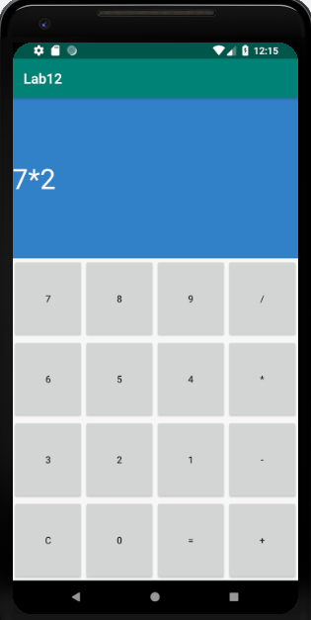 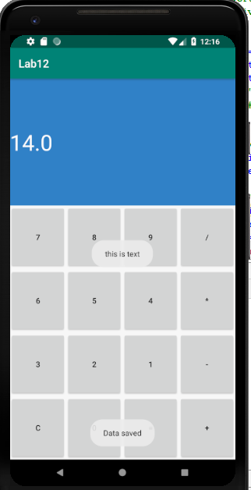

*Go Back and again start application saved data will appear in text box.*

